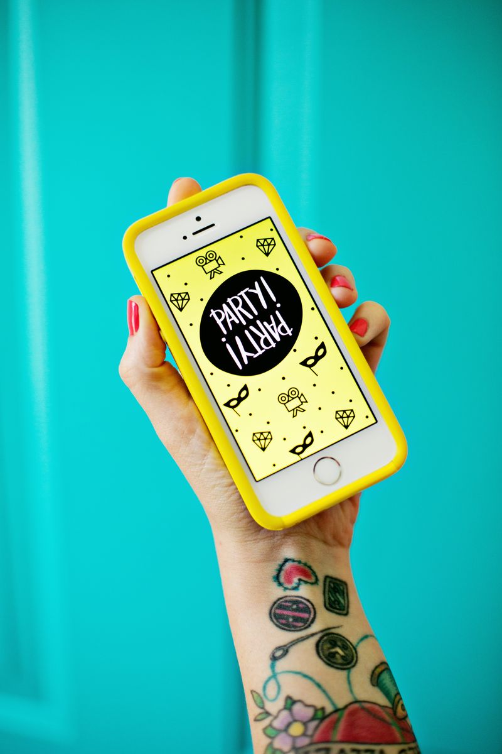

Party Party App Review
Roxanne Coble
10/20/14

Being an artist and blogger, I frequently stumble into new apps that other creative people are using or developing. At the start of the year, there was one particular app that seemed to really take the blogosphere by storm: Party Party. Developed by two creative bloggers from A Beautiful Mess, the app takes a fun approach to creating stop-motion videos and photo booth-like filmstrips.
The app features two main components: the stop motion animation and photo square collage and strip. The stop motion portion of the app allows you to take photos, use a timer feature, or even import your own individual photos to build the animation. From there you can customize your animation by adding filters, adjusting the speed, or even adding a frame around your stop motion short. What makes this feature especially functional is that you can download or save the animation straight to your phone as a gif or movie file. After saving, your animation can be uploaded easily to a website, shared on Instagram, or simply saved on your phone to share with others.
The second component of the app is similar to that of a traditional photo booth. By using still images (either taken through the app, or imported off your phone), you can create a photo collage or filmstrip. Similar to the animation, you can add filters and frames to customize your creation. This feature is particularly unique as there are not many apps that allow you to recreate a traditional photo booth filmstrip using your own imported images (most only allow you to use photos taken on the spot and within the app).
The positives with the app is that it is incredibly user friendly, customizable, and seems technologically up to date in both its look and feel. With high ratings and reviews both on the Internet and iTunes (5 out of 5 stars with over 250 reviews!), there are very little negatives with Party Party. The only real downside with this application (especially if used in a classroom), is that is not free. For .99 cents you can download Party Party directly from iTunes and onto your smartphone.
Purchase price aside, I see Party Party being used in the classroom in a number of ways. Students could easily use the stop motion feature to create short animations (with either drawn or photographed stills). Students would gain an introductory understanding of the animation process in creating their own animated shorts. The photo strip portion of the app could be used while studying the history of photography or even during a lesson on self-portraits. Taking a more modern approach to portraiture in art, students could even create a filmstrip of ‘selfies’ that feature various characteristics of self-portraits throughout art history.
During my trials of the Party Party app, I decided to use the stop motion feature to create a short video of one of my art journals. Using the timer within the app, I took photos of my journal as I flipped through the pages. After editing the speed and adding a filter, I ended up with a very unique way of quickly featuring my artwork. With my example completed, I realized students could also create very similar videos of their own to review their completed work, feature on a website, or even use during a special event (such as back to school night). In making a video similar to my example, students could learn how to curate and select artwork in a portfolio-like manner.
Party Party is fun, modern, user friendly, and something that could be very easily integrated into a high school classroom. With the only downside being the .99-cent cost, this app could ultimately be applied to a variety of lessons. Through the use of Party Party, students would only further their creative skills and curatorial eye all while using a technological tool.

