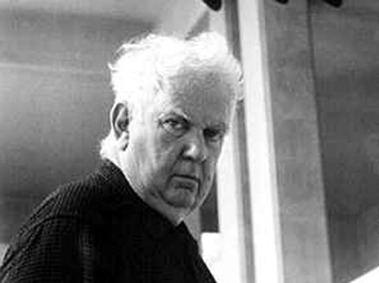

mobiles stabiles

_________________ ___________________
_________________ ___________________
_________________ ___________________

kinetic sculpture standing mobile
_________________ ___________________
_________________ ___________________
_________________ ___________________

MONDRIAN MIRO

__________________________ ____________________________
__________________________ ____________________________
__________________________ ____________________________
__________________________ ____________________________

#1

#2

#3

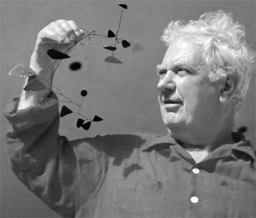

Using your sketchbook, write a one-page reflection on your experience at LACMA’s Calder and Abstraction: Avant-garde to Iconic exhibit.

After studying Alexander Calder, what was your experience seeing the work in person? Was it what you expected or different than what you thought you might see?

In your reflection, be sure to correlate your museum experience to what you’ve learned about the artist.

