Instructions for Using GifBoom

“GifBoom is a network for visual expressions.
Create beautiful photos, gifs or videos with the app
and instantly share to the world, your friends or just yourself.”

1.) On your iPhone, search and download the free version of GifBoom.

2.) After the program has loaded, open the app to begin.

3.) The app will ask you to enter a username and password to create an account.

4.) After establishing your log in information, you can edit the details of your account page by clicking ‘edit profile’. From here, you can import a profile photo, add a ‘cover gif’ (which is the gif featured on the top portion of your profile), change your main theme color, and share information about yourself. (see photo 1)

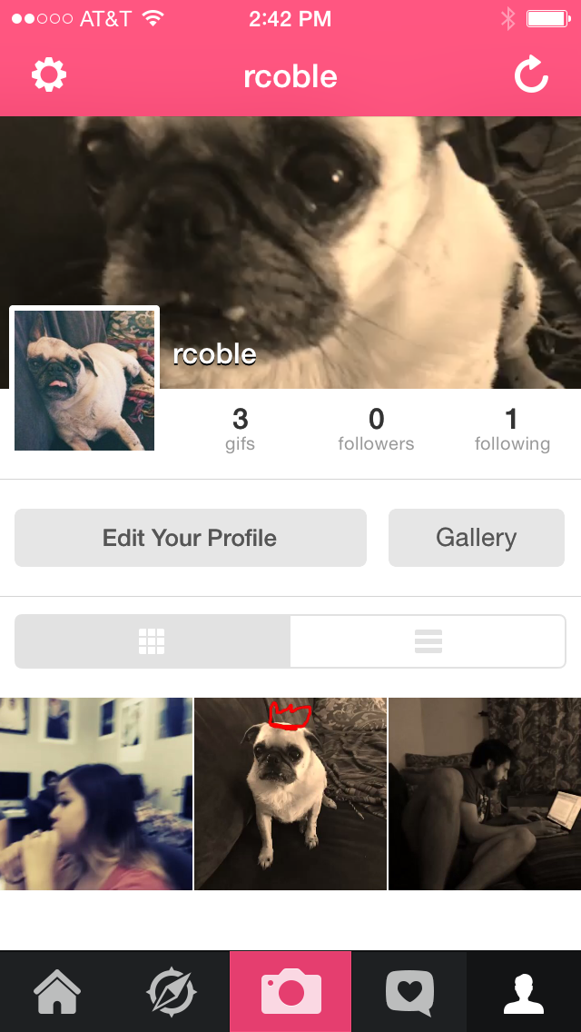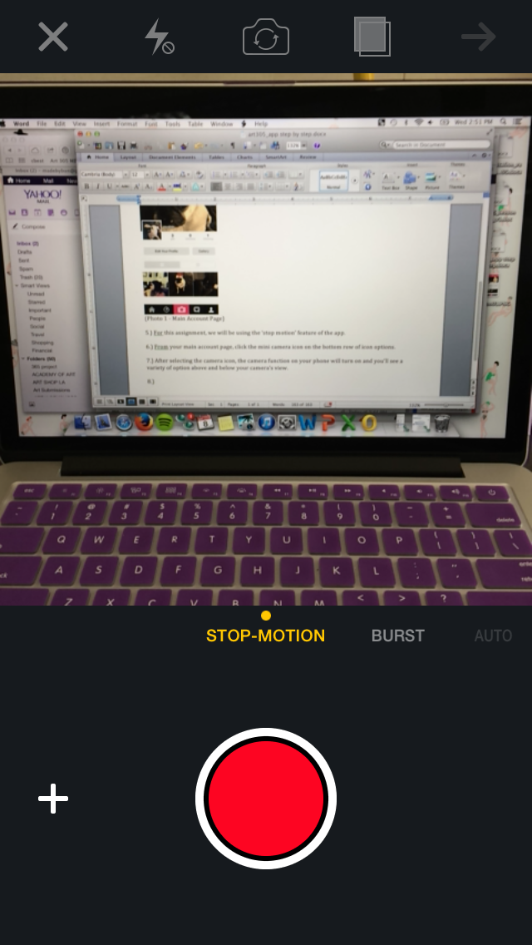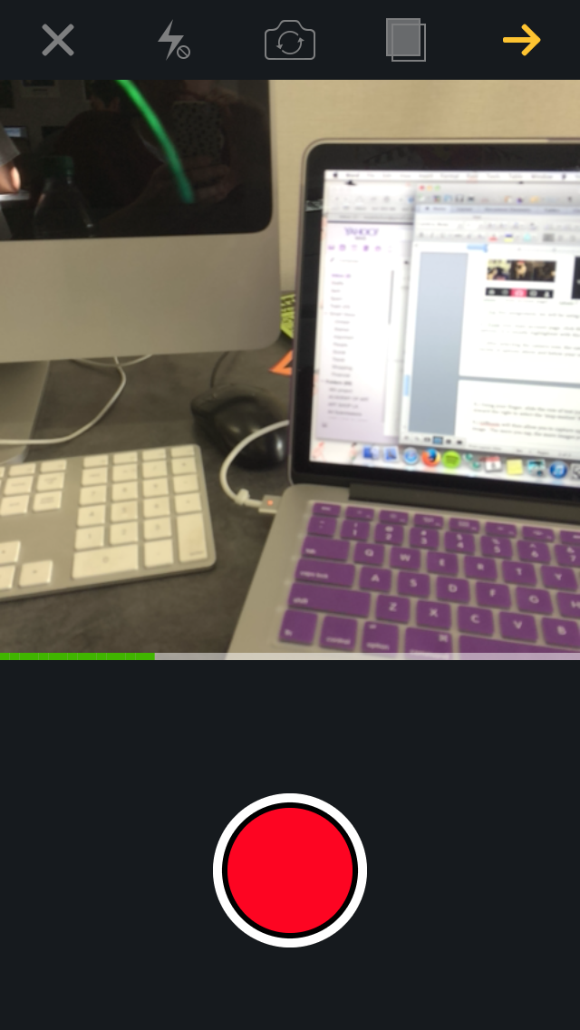
(photo 1 - main account page) (photo 2 – view after clicking the camera icon) (photo 3 – green progress bar)

5.) For this assignment, we will be using the ‘stop motion’ feature of the app.

6.) From your main account page, click the camera icon located in the center on the bottom row of icon options. It is usually highlighted with the theme color you chose for your account.

7.) After selecting the camera icon, the camera function on your phone will turn on and you’ll see a variety of options above and below your camera’s view. (see photo 2)

8.) Using your finger, slide the row of text just below your camera view (which is selected in yellow) toward the right to select the ‘stop-motion’ feature. (see photo 2)

9.) GifBoom will then allow you to capture up to 60 individual photos. Tap the red button to capture an image. The more you tap, the more images you will capture.

10.) As you take photos, a green slider bar will reflect the amount you have captured. When the green bar goes all the way to the right, you have hit the max number of photos you can take. (see photo 3)

11.) Once you are done taking still photos, you can tap the yellow arrow at the top right of the screen to move forward to the next step.

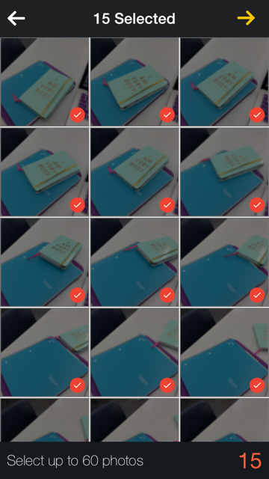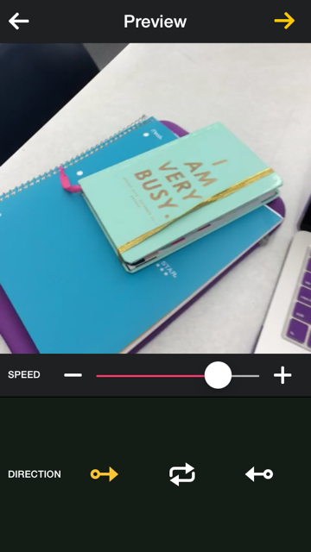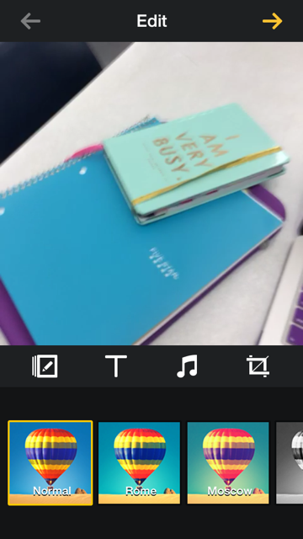
(photo 4 – grid of still photos) (photo 5 – Preview screen) (photo 6 – Edit screen)

12.) The app will then layout all of the images you have taken (up to 60) in a grid – where you can uncheck any photos you do not wish to use within your step motion video. Tap the red check marks to unselect a photo. (see photo 4)

13.) Once you’ve decided what photos you want to proceed with, tap the yellow arrow button in the upper right. To note, your photo total will be in the lower right in red.

14.) From the photo grid screen, you are now in the ‘Preview’ screen. Here, you can adjust the speed of your stop motion frames, and adjust the order of the stills. Use the tools on the bottom of the ‘Preview’ area to make any adjustments. Tap the yellow arrow in the upper right when you are done. (see photo 5)

15.) After the ‘Preview’ screen you will enter the ‘Edit’ screen of the app – where you can add a filter, text, music, or crop your video. Simply use the slider on the bottom to select a filter or tap any of the icons. When are done editing, tap the yellow arrow in the top right to proceed. (see photo 6)

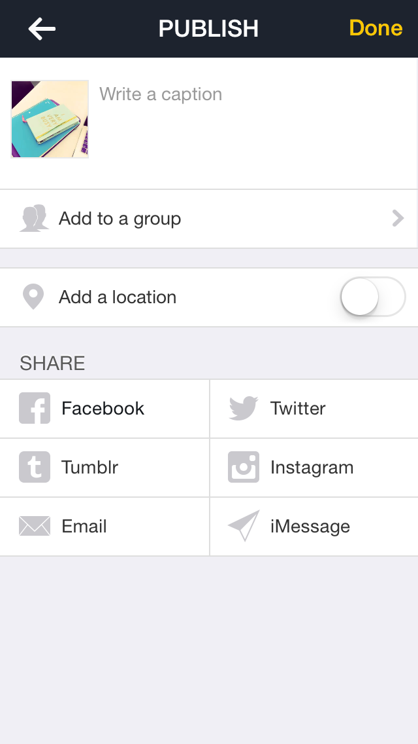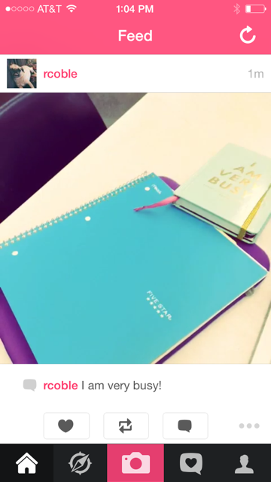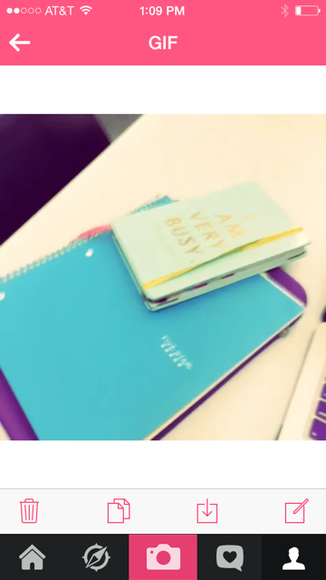
(photo 7 – Publish screen) (photo 8 – your GifBoom feed) (photo 9 – GIF screen)

16.) After the ‘Edit’ screen, you will now be in the ‘Publish’ screen of the app. Here, you can finalize your stop motion video by posting it to your profile, adding a caption, or sharing it across other social media apps. (see photo 7). In order to download your stop motion video or still from the video, you MUST PUBLISH it on your profile.

18.) After you have published your stop motion video it will appear in your ‘feed’. Your feed is essentially a timeline where your videos and others profiles follow will appear. (see photo 8)

19.) To download your stop motion video, go to your profile by tapping the head and shoulders icon in the lower right. From here, tap the ‘gallery’ button. In your ‘gallery’ all of your stop motion videos you have previously published will appear. Tap on the video you wish to download.

21.) Once you have selected your video, the ‘GIF’ screen will open. From here, you can make a number of actions using the icons just below your gif (such as delete, copy, download, or edit). Select the download icon. (see photo 9)

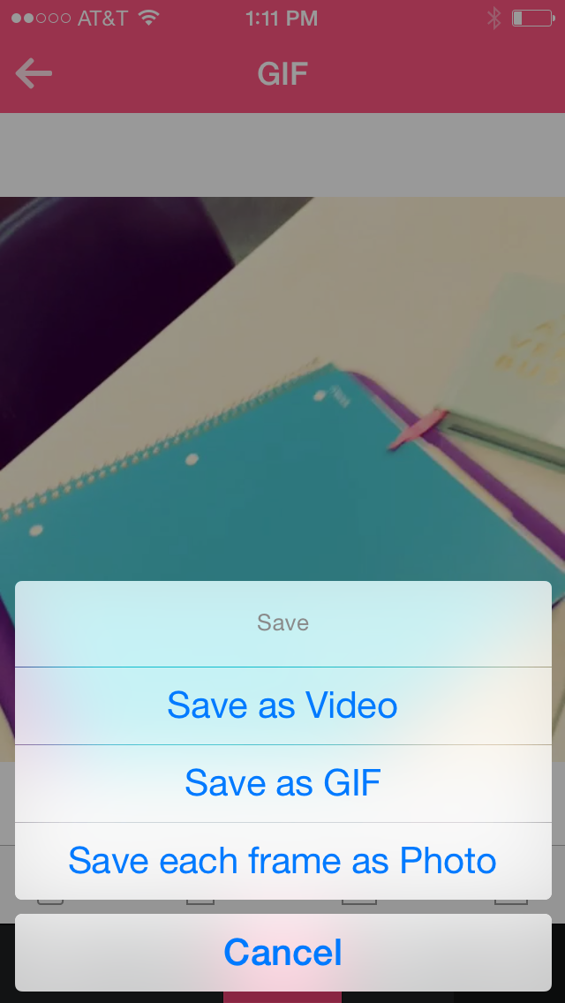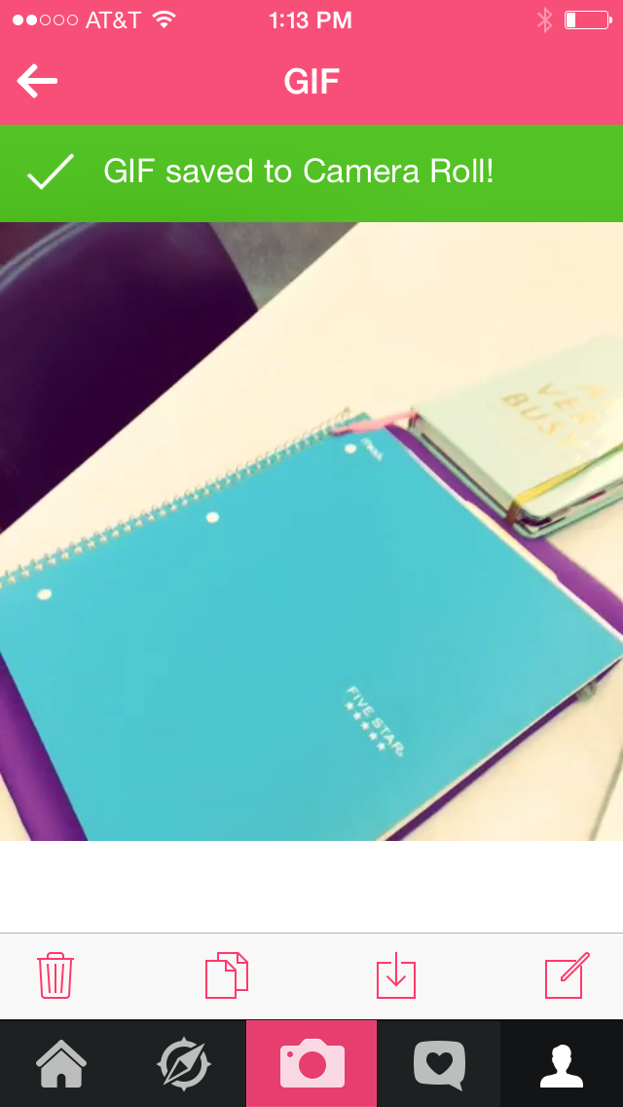
(photo 10 – saving options) (photo 11 – saved GIF confirmation)

22.) After selecting the ‘download’ icon, a drop down ‘save’ menu will appear. You can save your stop motion video as a video, gif, or as individual photos. (see photo 10)

23.) For this assignment, you will save your stop motion video as a ‘GIF’. Once you have selected ‘GIF’ it will automatically save to your camera roll on your phone. Email the video to yourself to save, and upload to your class website to complete the assignment!

